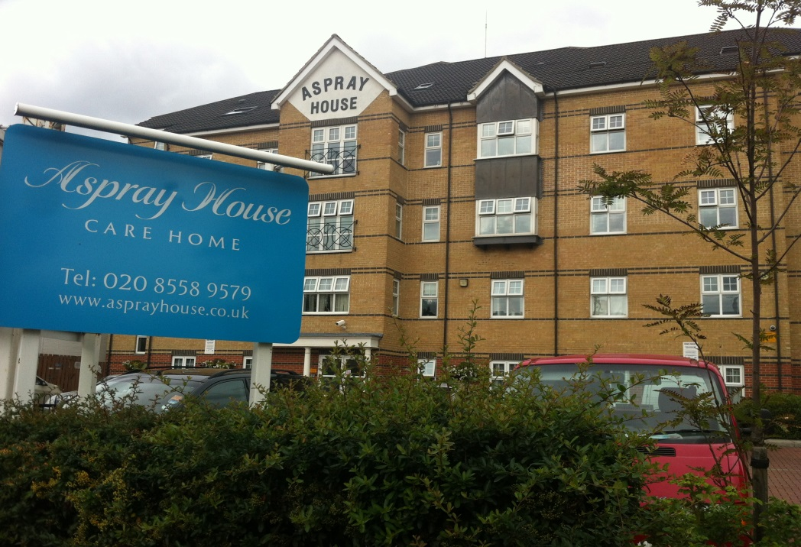

Contents
• • •
Welcome
Activities
Home Decoration
Mother’s Day
Easter
Staff Update
Meetings
Car Boot Sales
Online
Birthdays

Aspray House
481 Lea Bridge Road
London
E10 7EB
Tel: 020 85589579
Aspray House Newsletter
Twinglobe Care Homes Ltd |  | March 2014

Welcome
Welcome to the third edition of our newsletter featuring all the latest news from Aspray House including important dates for your diary and a staff update.

Activities
We already have an exciting line-up of entertainment planned for this year with more entertainers to be added.
Shakti recently visited Aspray for her second music and movement class following the popularity of her first session.

Singer Chris Ryan is next on the line-up and she will be singing on March 28th while Brian Shaw will be returning to Aspray on April 11th with his show Let’s Twist Again.
On May 15th Tickled Pink will be bringing the sounds of the musicals to Aspray with their show The Best of Broadway.
Please see the posters around the home for information about the location and time of performances.
Home Decoration
As well as planning the entertainment Sonia and Elise have also been busy adding decorations to the walls around the home including those pictured below.
This tree mural has been added to the wall in reception.
Audrey Hepburn now adorns the wall of the cinema room which is located on Emerald Floor.
We are also in the process of decorating our Activity Room to transform it into a much brighter space.
Mother’s Day
Mother’s Day is on Sunday March 30th and residents will be receiving delicious cupcakes and treats for their evening tea prepared by the kitchen staff.
Easter
To celebrate Easter we will be holding an Easter egg hunt around Aspray on 18th April. Keep your eyes peeled for hidden paper eggs and exchange them for a chocolate treat from Activities.
Sonia and Elise will also be running an Easter raffle to raise money for the residents’ activity fund. If you have any prizes you wish to donate please let Sonia or Elise know.
Staff Update
Alexia is joining our activity team and we would like to take this opportunity to welcome her to Aspray House.
Meetings
The dates are set for our relatives and residents meetings. This is your chance to hear about all the latest updates from Aspray House and to let us know what you would like to see.
The dates for the meetings are:
Saturday May 17th at 2.30pm
Friday July 4th at 2.30pm
Tuesday November 25th at 6.30pm

Car Boot Sales
Following the success of our car boot sales last year, this year we will be holding our first sale on Saturday May 31st from 10am until 1pm.
Pitches cost £8 and to book please speak to Activities or call 020 85589579.
Online
You can now keep up to date with all the latest news from Aspray House through a variety of online platforms.
You can follow us on Twitter @Twinglobe for the latest news and photos.
In addition to our website www.twinglobe.co.uk we are also listed on www.carehome.co.uk where information includes dates of forthcoming entertainment and job vacancies.

Birthdays
We would like to wish a Happy Birthday to all residents who will be celebrating over the next three months.
We will be decorating rooms and having a birthday cake to mark the occasion. Please let us know if there is anything particular you would like us to do for your relative on the day.

