Contents
• • •
Welcome
Staff
Activities
Mother’s Day
Easter
Tapas Evening
Meetings
Garden
Online
Birthdays

Azalea Court
58 Abbey Road
Bush Hill Park
Enfield
EN1 2QN
Tel: 0208 3701750
Azalea Court Newsletter
Twinglobe Care Ltd |  | March 2014

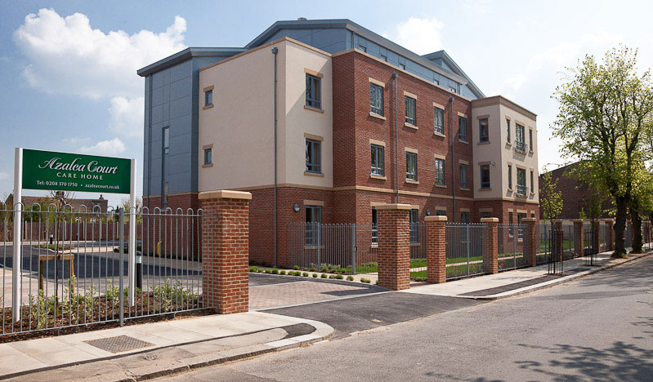

Welcome

Welcome to the third edition of our newsletter.
Inside this issue you will find all the latest news and information about life here at Azalea Court including staff appointments and dates for you diary.
Staff
There have been a few changes at Azalea Court since the last newsletter. Julie Burton remains in charge of the home as Head of Operations while we would like to welcome Janet Usedon as our Deputy Home Manager.
We would also like to welcome all the nurses who have joined us at Azalea Court during the last three months.

Activities
We have an exciting line-up of entertainment planned for this year and a list showing what we have booked so far is available on the notice board by the lift on each floor.
This month we have already welcomed Mick Ryan and a Swing Quartet made their first visit to Azalea Court on the 19th. Tina’s Clothing will be returning to the home on the 26th with their spring collection and you can leave money for your relative with Admin or Activities.
On April 15th Brian Shaw will be visiting us once again with his show There Will Always Be an England and he will be back on May 13th with Let’s Twist Again. Also in May Jodie Stone will be singing on the 28th and Tickled Pink will be performing The Best of Broadway on the 30th. For timings and locations please see the posters around the home which advertise the events.
The Activity Room on the second floor has been transformed into a much brighter space with a wall dedicated to each floor and we hope this will give residents an enjoyable change of scene.
Danielle has decorated her wall with a variety of photographs showing the residents enjoying activities. Why not bring your relative to the activity room and see if they can find their picture on the wall.
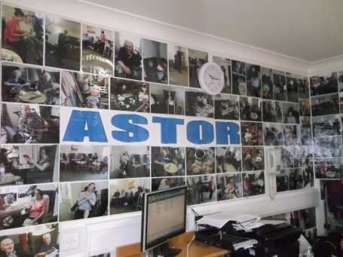

Daisy has decorated her wall with photographs and examples of the art work created by the residents.
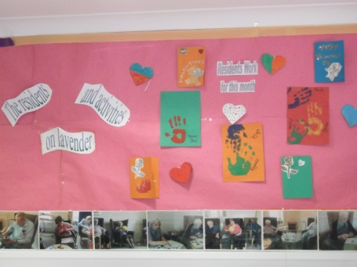

Kathryn worked with the residents to create poppies during arts and crafts activities. She then painted the wall green and placed the poppies on the wall.
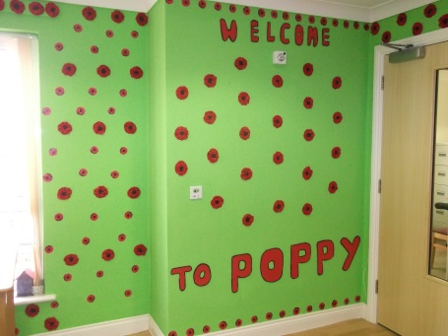

Arts and crafts sessions have been held in the new look activity room where residents took part in painting.
We have established a monthly fish and chip lunch with food bought from the local chippy. The next one will be on Wednesday April 16th. The sign-up sheet will be on the activity table in the entrance foyer.
Mother’s Day
You are invited to join your Mum to enjoy afternoon tea including sandwiches, tea and cake on Sunday March 30th to celebrate Mother’s Day.

Easter
To celebrate Easter we will be holding an Easter Egg hunt on each floor on Monday April 21st at 3pm. Please join in the fun as we hunt for eggs around the home.
And keep your eyes peeled for an Easter treat in reception.
Tapas Evening
You are invited to join us for our next social event. We will be holding a Tapas Evening on Wednesday April 9th from 7pm until 9pm.
Meetings
Every month we hold multi-disciplinary meetings with our GP in conjunction with Azalea Court’s aim to achieve the Gold Standard Framework. Personalisation of care is our key objective and we will keep you updated as to our progress.
We will be holding a health and safety meeting on Thursday April 3rd at 10am.
If any relatives are interested in joining the Health and Safety Committee or the Relatives Committee, where you will be able to work with home management to discuss fundraising opportunities, please speak to Julie.
Garden
Are you a green fingered gardener? Do you belong to a gardening club? We are looking for people who would be willing to help out on our garden project. We have plans for a greenhouse, raised flowerbeds, a herb garden and hanging baskets. If you would like to get involved please speak to the activity team.

Online
You can now keep up to date with all the latest news from Azalea Court through a variety of online platforms.
You can follow us on Twitter @Twinglobe where we will post the latest news and photos.
In addition to our website www.twinglobe.co.uk we are also listed on www.carehome.co.uk where information includes forthcoming entertainment and job vacancies.
Birthdays
We would like to wish a Happy Birthday to our residents who will be celebrating over the next three months.
We will be decorating rooms and having a birthday cake to mark the occasion. Please let us know if there is anything particular you would like us to do for your relative on the day.

