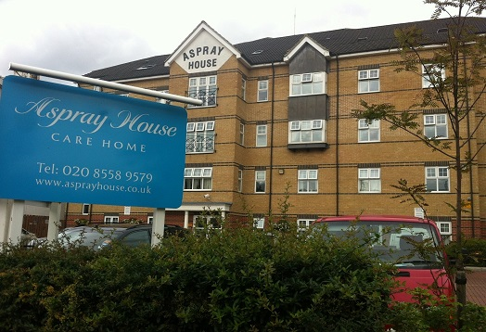

Welcome to the December issue of our newsletter. It’s not long to go until Christmas and the home is decorated for the festive season. The residents have enjoyed Christmas shows and there is still a variety of entertainment to look forward to. Details can be found on page two. We would like to wish you all a Merry Christmas and a Happy New Year.

# Welcome

# Christmas Greetings

Inside This Issue

Welcome

Christmas Greetings

Christmas Bazaar

Activities

Dementia Champion

Feedback

Recommendations

Online

Birthdays

I would like to wish everyone a happy holiday. May the spirit of Christmas not only fill your heart and soul but also spread to your loved ones

I would also like to take this opportunity to give my appreciation to the residents and relatives who attended our recent meeting where there was a good turnout.

We discussed suggestions and plans together on how to move forward with the ongoing issues and concerns raised. These will allow us to build a good relationship with the residents, relatives and visitors.

Jade Shea

Home Manager.

Aspray House Newsletter

Twinglobe Care Homes Ltd December 2014



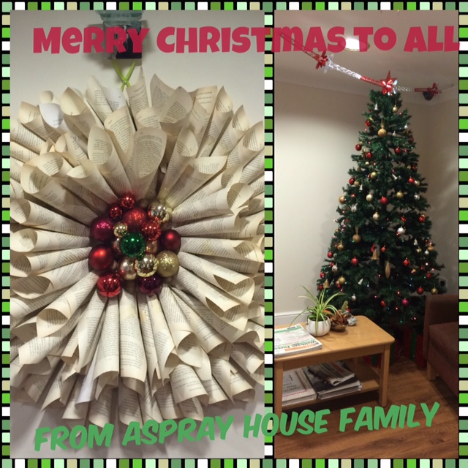 

# C:\Users\laura.payne\AppData\Local\Microsoft\Windows\Temporary Internet Files\Content.IE5\W3PX03PJ\MC900436386[1].pngChristmas BazaarC:\Users\laura.payne\AppData\Local\Microsoft\Windows\Temporary Internet Files\Content.IE5\W3PX03PJ\MC900436386[1].png

We welcomed visitors to Aspray House on December 6th for our Christmas Bazaar. There was a selection of stalls selling a range of items including gifts, jewellery, sweets, and refreshments. Our raffle proved popular with brilliant prizes up for grabs including some fabulous hampers as pictured below. Residents spent time browsing the stalls accompanied by their family and friends. Money raised from the event will go towards activities such as trips. We hope everyone who came enjoyed the event and left feeling festive.

# C:\Users\laura.payne\Desktop\photo 1.JPG

# Activities C:\Users\laura.payne\AppData\Local\Microsoft\Windows\Temporary Internet Files\Content.IE5\W3PX03PJ\MC900436386[1].png C:\Users\laura.payne\AppData\Local\Microsoft\Windows\Temporary Internet Files\Content.IE5\2HGAUT35\MC900285794[1].wmf C:\Users\laura.payne\AppData\Local\Microsoft\Windows\Temporary Internet Files\Content.IE5\W3PX03PJ\MC900250802[1].wmf C:\Users\laura.payne\AppData\Local\Microsoft\Windows\Temporary Internet Files\Content.IE5\FK3FS814\MC900363558[1].wmf C:\Program Files (x86)\Microsoft Office\MEDIA\CAGCAT10\j0299587.wmf C:\Users\laura.payne\AppData\Local\Microsoft\Windows\Temporary Internet Files\Content.IE5\W3PX03PJ\MC900436198[1].png

This month Hainault Church Children’s Choir have already visited Aspray House to sing to residents. Dream Worldwide Productions also performed festive favourites during their show Winter Wonderland.

**  We will be welcoming Olivia back to Aspray on December 17th at 11am for Musical Memories.

C:\Users\laura.payne\AppData\Local\Microsoft\Windows\Temporary Internet Files\Content.IE5\W3PX03PJ\MC900250802[1].wmf Then Brian Shaw will be performing his Christmas show on December 18th at 5.15pm.

C:\Users\laura.payne\AppData\Local\Microsoft\Windows\Temporary Internet Files\Content.IE5\FK3FS814\MC900363558[1].wmfChris will bring the festive feeling to Aspray on December 23rd as he performs from 2.30pm.

C:\Program Files (x86)\Microsoft Office\MEDIA\CAGCAT10\j0299587.wmf Sonia and Elise will be hosting a Christmas Party on December 24th.

 On Christmas Day Sonia and Elise will visit all the residents to hand out Christmas presents.

** The Swing and Sing Quartet will be bringing the festive entertainment to a close on December 30th at

2.30pm.

# Dementia Champion

Our Dementia Champion Alex will be joining us for the final time on January 15th. She has been visiting Aspray House for several months and working with staff as part of the Improving Wellbeing and Health for People with Dementia (WHELD) research programme. Activities during this time have included growing herbs and seaside themed sensory sessions. The Activity Team are currently in the process of putting together CDs of music for individual residents as a result of their work with Alex.

We would like to thank Alex for the time she has spent with us.

# Feedback

We would like to hear from you. Your feedback helps us to identify where we are doing well and any areas where we can improve. We will be leaving surveys in residents’ rooms and at reception. We would be extremely grateful if you could take the time to fill one in and return it to reception by Friday January 30th.

# Recommendations

If you can, please take the time to complete a recommendation card for Aspray House. These are available in reception and all comments go to [www.carehome.co.uk](http://www.carehome.co.uk)

# Online

We post all the latest news and photos on our website and Twitter.

You can log on to [www.twinglobe.com](http://www.twinglobe.com) or follow us on Twitter @twinglobe.

# C:\Users\laura.payne\AppData\Local\Microsoft\Windows\Temporary Internet Files\Content.IE5\2HGAUT35\MC900021592[1].wmfBirthdays C:\Users\laura.payne\AppData\Local\Microsoft\Windows\Temporary Internet Files\Content.IE5\2HGAUT35\MC900021592[1].wmf

We would like to wish all our residents celebrating this month a Happy Birthday.

C:\Users\laura.payne\AppData\Local\Microsoft\Windows\Temporary Internet Files\Content.IE5\2HGAUT35\MC900430219[1].wmf