Contents
• • •
Welcome
Activities
Residents’ Meeting
Fireworks
Uniforms
Picture Boards
Menus
Flu Jab
Relative Committee
Relative Meeting
Relative Get Together
Christmas
Message from Julie
Recommendations
Twitter
Birthdays

Azalea Court
58 Abbey Road
Bush Hill Park
Enfield
EN1 2QN
Tel: 0208 3701750
Azalea Court Newsletter
Twinglobe Care Ltd |  | October 2014

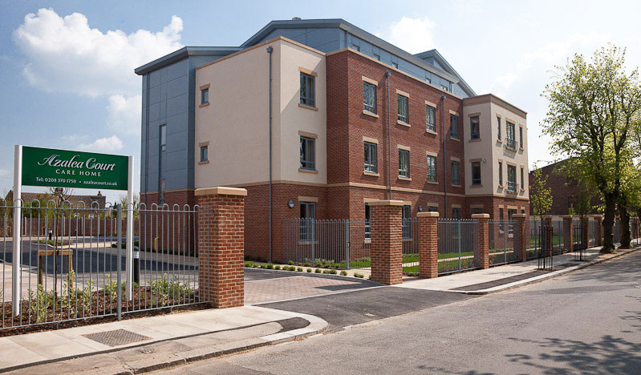

Welcome

Welcome to the October edition of our newsletter. This month’s issue features information about a number of relative events for you to get involved in over the coming months. You will also find details about our uniform changes and exciting news about our plans for Bonfire Night.
Activities
This month we will welcome Tickled Pink to Azalea once again on October 21st with their show The Swing Shift which will be packed full of Big Band Classics.
Then later in the month things will turn a little spooky for Halloween on October 31st when the Activity Team will be holding parties on all floors.
Danielle and Kathryn recently attended a training day run by National Association for Providers of Activities for Older People (NAPA). They will be writing a summary of their experiences in next month’s
newsletter.
Residents’ Meeting
The Activity Team recently held a Residents’ Meeting. Following on from their discussions the following changes will be implemented:
- More group discussions will be added to the activity programme.

- Extra exercise sessions will be organised for Lavender as requested.

- There will be an outing to the coffee shop every Thursday morning. If you would like to go along please speak to the Activity Team.

- A fish and chip lunch will be held in the activity room once a month and if you would like to join them please let the Activity Team know.

- The Activity Team will look at purchasing more equipment such as games, arts and crafts, pots and plants and jigsaws.
The next Residents’ Meeting is scheduled for December 1st and the location will be advertised on the noticeboards nearer the time.
Fireworks
We are organising a Firework display on November 5th for residents and their friends and families. The fireworks are due to begin at 6.30pm and food will be available.
If you are interested in attending please let us know by completing the form at the end of the newsletter.
Uniforms
As you may have noticed we have introduced new uniforms following discussion with our staff. These have proved successful offering greater practicality and more comfort.

The colours correspond to the various positions as follows:

Nurse – Unit Manager
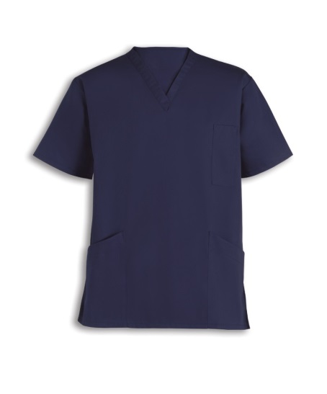

Nurse
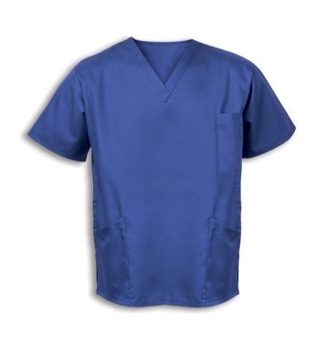

Senior Carer
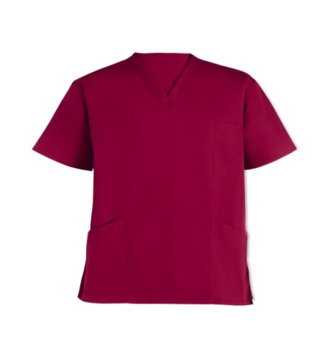

Carer
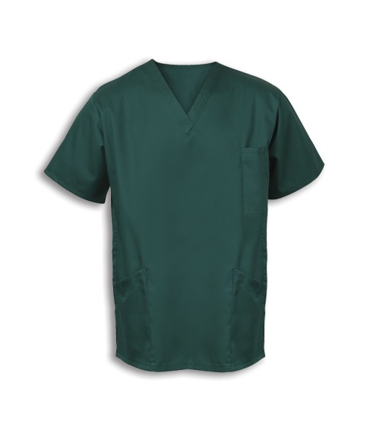

Picture Boards
We have made it easier for you to identify which staff are on duty at Azalea Court. We now have picture noticeboards on each floor where photos will be displayed to show which staff are on duty for each shift. We hope this will be a helpful addition to the home.

Menus
New guidelines for menus set out by the Food Standards Agency come into force in December and we are currently working on adopting these. The changes will see alterations to the way food is labelled and will clearly set out allergens.
Audra is working towards meeting with families to discuss individual needs.

Audra is also in the process of putting up boards in each dining room which will display the week’s menu. We hope you will find these to be another useful addition to the home.

Flu Jab
We are reaching that time of year again when residents are offered the Flu Jab to protect them during the winter months. If you would like your relative to have the jab please can you speak to the appropriate Unit Manager or complete the consent form which is available at Reception.

Relative Committee
We are looking to set up a Relative Committee. This will be your chance to raise points for discussion and suggest what you’d like to see at Azalea Court. If you are interested in joining the committee please contact Julie.

Relative Meeting
The next Relative Meeting will take place on Thursday November 13th at 7.30pm. If you wish to attend please complete the form at the end of the newsletter.

Relative Get Together
You are invited to attend our Relative Get Together on Friday December 12th at 7.30pm. This will be a great chance for you to meet and chat to other relatives, plus there will be mulled wine and festive food for you to enjoy. If you wish to attend please complete the form at the end of the newsletter.
Christmas
As we creep closer to Christmas we are starting to plan for this year’s festivities and we would like to hear your ideas. In the past few years residents have enjoyed going to the theatre at Christmas and seeing the lights in London. Do you have any recommendations or suggestions of other places we could visit? If so please speak to the Activity Team.

This year our decorations will go up throughout the home on Monday December 1st. Our Activity Team work very hard to transform the home but if anyone could lend a hand it would be much appreciated. If you would like to offer your help please speak to any of the team.

You are invited to join your relative for Christmas dinner. If you would like to be there please can you let us know by filling in the form at the end of the newsletter.

Message from Julie
Julie would like to thank everyone for their kind words and best wishes following her accident.

Recommendations
We are always interested in hearing what you have to say about the services we provide. Recommendation cards are available to complete in reception and we would be grateful if you could take the time to fill one in. These comments are sent to www.carehome.co.uk and you can also submit feedback on their website.

In addition we also have a compliments book in reception where you can leave your comments and this is checked regularly by management.

Twitter
You can keep up to date with all the latest news and information from the company by following us on Twitter @twinglobe.

Birthdays
We would like to wish all our residents celebrating this month a Happy Birthday.

