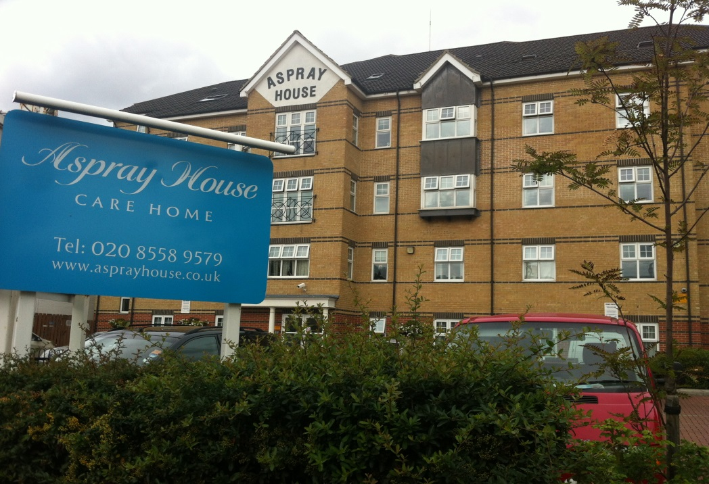

Contents
• • •
Welcome
Activities
Dementia Champion
Meeting
Flu Jab
Online
Recommendations
Birthdays

Aspray House
481 Lea Bridge Road
London
E10 7EB
Tel: 0208 5589579
Aspray House Newsletter
Twinglobe Care Homes Ltd |  | October 2014

Welcome
Welcome to the October newsletter from Aspray House. This month’s edition includes an update on the activities our Dementia Champion and Activity Team have carried out over the last few months.

Activities
This month we have already welcomed Shakti back to Aspray House. She entertained residents on October 13th with a music and movement session where she was accompanied by her drummer. All the residents enjoyed the afternoon and we look forward to welcoming her back.

Things will take a spooky turn on Thursday October 30th when Dream Worldwide productions perform their Halloween themed show Monster Mash and the Halloween celebrations will continue during activities the following day.
Dementia Champion
Over the last few months Elise and Sonia from our Activity Team have been working closely with Alex as part of the Wellbeing and Health for People with Dementia (WHELD) project.
The aim of the project is to look at whether staff support and coaching to provide person centred care and activities for people with dementia are effective in improving the mental health and well-being of residents.
As part of the programme, activities have included growing cress and lettuce which were then used in residents’ food. A group of residents also helped to make guacamole which they enjoyed tasting. Alex led a further session alongside the Activity Team encouraging residents to reminisce about going to the seaside, using a bucket, sand, shells and postcards.
Most recently Alex brought in some dolls to conduct a doll therapy session with residents who it was felt would benefit from this type of activity and this was a great success.
Meeting
The next Resident and Relative Meeting will be held on Tuesday November 25th at 6.30pm in Emerald Lounge. This is your chance to let us know what you would like to see at Aspray House and to hear about upcoming events. We look forward to seeing you there.
Flu Jab
We are reaching that time of year again when residents are offered the Flu Jab to protect them during the winter months. If you would like your relative to have the jab please can you let the Home Manager know as we need consent in order to administer it.

Online
We are on Twitter. To keep up to date with all the latest news, information and photos you can follow us @twinglobe
Recommendations
We would like to thank people for their kind comments about the services we provide here at Aspray House.
If you would like to give us your feedback then please fill in one of the recommendation cards which can be found in reception by the signing in book. We are also listed on www.carehome.co.uk where you can add your recommendation.
Birthdays
We would like to wish all our residents celebrating this month a Happy Birthday.

