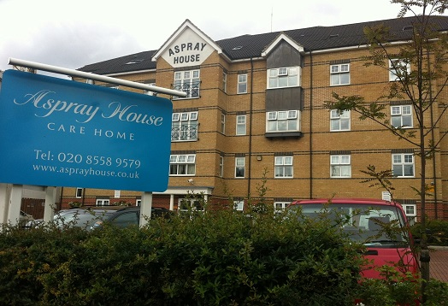

Welcome to the November edition of our new look newsletter.

This month’s newsletter is packed with information about all the exciting events we have planned for Christmas.

We have also been awarded a five star rating, more details of which can be found on page two.

# Welcome

# Activities

Inside This Issue

Welcome

Activities

Christmas

Medical Students Visit

Meeting

Donation

Five Star Rating

Recommendations

Online

Birthdays

Olivia will be visiting Aspray on Thursday November 20th at 11am for another Musical Memories session.

On December 3rd Debbie’s Fashion will be bringing in a range of winter clothes. Please speak to Elise or Sonia from the Activity Team for more information.

Aspray House Newsletter

Twinglobe Care Homes Ltd November 2014



# C:\Users\laura.payne\AppData\Local\Microsoft\Windows\Temporary Internet Files\Content.IE5\W3PX03PJ\MC900436386[1].pngChristmasC:\Users\laura.payne\AppData\Local\Microsoft\Windows\Temporary Internet Files\Content.IE5\W3PX03PJ\MC900436386[1].png

Are you getting that festive feeling? Well you certainly will be on Saturday December 6th when we hold our Christmas Bazaar. There will be a variety of stalls including gifts, sweets, and refreshments while some brilliant prizes will be up for grabs in the raffle. Please speak to the Activity Team if you would like to donate a prize to our raffle or have any other quality items which you think would suit one of our stalls. The Bazaar will open at 2pm. Entry is £2 which includes automatic entry into the raffle.

As well as the Bazaar, December will be packed with festive entertainment taking place at Aspray.

** On Monday December 8th Hainault Church Children’s Choir will be singing to residents from 5pm.

** Then on December 10th Dream Worldwide Productions will be singing festive favourites during their show Winter Wonderland at 3.30pm.

**  We will be welcoming Olivia back to Aspray on December 17th at 11am for another Musical Memories session.

** Then Brian Shaw will be performing his Christmas show on December 18th at 5.15pm.

** Chris will bring the festive feeling to Aspray on December 23rd as he performs from 2.30pm.

** With just one day to go Sonia and Elise will be hosting a Christmas Party on December 24th.

** The Swing and Sing Quartet will be bringing the festive entertainment to a close on December 30th at 2.30pm.

For more information about any of the entertainment please check the noticeboards.

We have been awarded the top five star rating following an inspection conducted by an Environmental Officer looking at food hygiene in Aspray House.

The officer spent time checking the premises to monitor food safety, taking into account how food is cooked and prepared as well as other factors such as the cleanliness of the premises.

We will be sent a sticker which will be displayed in the home as evidence of our five star rating.

The officer said: “I was pleased to note the high standard of food safety management in the business.”

# Five Star Rating

# Donation

# Meeting

Thanks to one of our suppliers Total Medcare Pharmacy who have kindly donated £200 to the home. Some of the money will go towards our Christmas Bazaar.

The next Resident and Relative Meeting will be held on Tuesday November 25th at 6.30pm in Emerald Lounge. This is your chance to let us know what you would like to see at Aspray House and to hear about upcoming events. We look forward to seeing you there.

We were delighted to welcome students from The Firs Medical Centre in Walthamstow to Aspray House for two days recently. They spent time looking around the home, meeting residents and staff and finding out more about how a care home is run.

John Clarke, a tutor from the centre, said his students found the experience valuable and they particularly enjoyed taking part in a question and answer session.

He said: “The general feeling about the visit to the home is that it has left us all with the valuable knowledge of what it involves in providing a range of services and efficiently; to a home the size of yours.

“In fact, the professionalism and staff friendliness, coupled with the serene atmosphere of the home has left a positive and indelible impression of the home on us, and a wish that future students can also benefit from the same learning experience by visiting your home.

“Finally, the Medical Students and Co-GP Tutors of the module at the Firs Medical Centre in Walthamstow, join me in expressing our most sincere thanks for welcoming and showing us around your home; many thanks to you and your staff once again - thank you.”

# Medical Students Visit

# Recommendations

We are always interested in hearing what you have to say about the services we provide.

Recommendation cards are available in reception and we would be grateful if you could take the time to fill one in.

These comments are sent to [www.carehome.co.uk](http://www.carehome.co.uk) and you can also submit feedback on their website.

In addition we also have a compliments book in reception where you can leave your comments and this is checked regularly by management.

# Online

We post all the latest news and photos on our website and Twitter.

You can log on to [www.twinglobe.com](http://www.twinglobe.com) or follow us on Twitter @twinglobe.

# C:\Users\laura.payne\AppData\Local\Microsoft\Windows\Temporary Internet Files\Content.IE5\2HGAUT35\MC900021592[1].wmfBirthdays C:\Users\laura.payne\AppData\Local\Microsoft\Windows\Temporary Internet Files\Content.IE5\2HGAUT35\MC900021592[1].wmf

We would like to wish all our residents celebrating this month a Happy Birthday.

C:\Users\laura.payne\AppData\Local\Microsoft\Windows\Temporary Internet Files\Content.IE5\2HGAUT35\MC900430219[1].wmf