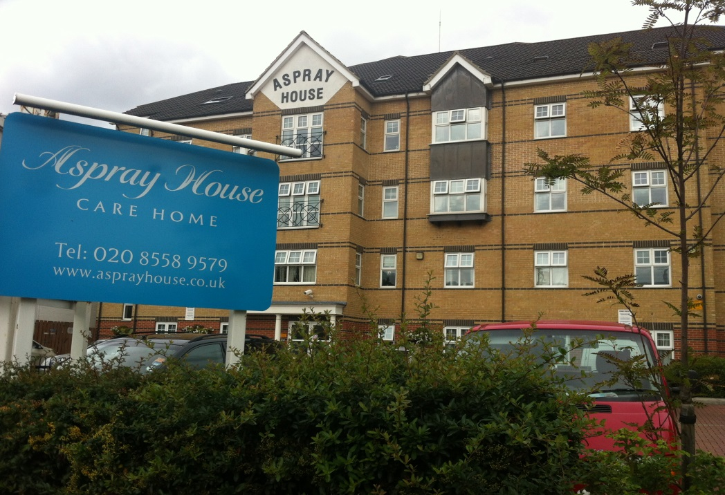

Contents
• • •
Welcome
Staff Update
Activities
Meeting
Car Boot Sale
Dementia Champions
Home Decoration
Tour de France
Sky TV
Online
Hairdressing
Feedback
Birthdays

Aspray House
481 Lea Bridge Road
London
E10 7EB
Tel: 020 85589579
Aspray House Newsletter
Twinglobe Care Homes Ltd |  | June 2014

Welcome
Welcome to the fourth edition of our newsletter. This issue is packed full of the latest news and information from Aspray House including a staff update and dates for your diary.
Staff Update
Wendy is leaving Aspray House after three and a half years with the company. She said: “I would like to thank the families for their support during my time at Aspray. I will miss them all.”
Jade is taking over as the Home Manager and we would like to welcome her to

the company. Jade has a wealth of experience and she said she always puts the residents at the centre of care while looking for innovative ways to improve the care service.
She said: “I’m delighted to be taking on this role and to be joining the team at Aspray House. I will always look forward for the betterment of the residents, staff and the home, promoting the continuity of care and relationship building within the care setting.”

Activities

Debbie’s Fashions are returning to Aspray on Monday June 9th with a selection of summer clothes. Shakti is also making a return visit in June on Friday 20th for another music and movement session. And on Wednesday June 25th the Swing and Sing Quartet will be visiting Aspray for the first time.
Moving into July Dream Worldwide Productions will be making their first visit to Aspray House on Friday 18th with their show Strictly Musicals. And Chris will be entertaining us once again on Friday August 8th.
We are also planning a series of themed activities to coincide with the World Cup. Decorations will be put up in the lounges and there will be themed food. Keep your eyes peeled for information on the notice boards.

Meeting
The next Relatives and Residents Meeting will be held on Friday July 4th at 2.30pm on Emerald.
Car Boot Sale
Thanks to everyone who came along to our Car Boot Sale on May 31st and helped us to raise money for our residents’ fund. Our next sale is due to be held on September 6th.
Dementia Champions
Aspray House is participating in the Improving Wellbeing and Health for People with Dementia (WHELD) research programme which is funded by the National Institute for Health Research. The programme was devised after the National Dementia Strategy for England highlighted the need to improve the well-being of people with dementia by providing effective psychological and social approaches to person centred care.
The project will examine whether staff support and coaching to provide person centred care and activities for people with dementia are effective in improving the mental health and well-being of residents.
Activity staff and members of staff on first floor who have been nominated as Dementia Champions are working with a research therapist from the project who is providing training to promote person centred activities and interactions.
The findings from the research will be shared locally through training events and articles while they will also be published in academic journals.
Home Decoration
Do you have any sports equipment or memorabilia you no longer need? Sonia, Elise and Alexia are working on adding more to the corridors around the home inspired by various themes including sport. If you have anything you would like to donate please speak to the Activity Team.
Tour de France
The Tour de France will be cycling past Aspray House on Monday July 7th which means there will be no access to the home from 10am until 6pm. Emergency vehicles will still be allowed through.
Residents will be able to watch as the cyclists whizz pass Aspray House as part of the third stage of the race which goes from Cambridge to London.
Sky TV
We are delighted to inform you that Sky TV will soon be available to have in your room. Thanks to our partnership with Sky we have secured an excellent rate and for your convenience payments would be made directly to us with a notice period of just 30 days.
There are various packages available and we are currently in the process of finding out how many residents are interested.
Online
We have some new features on our website. There is now a news and events tab where we will be posting information about the latest developments at Aspray House including upcoming events and our newsletters.
Our galleries have also been re-designed to make the photos more accessible. To take a look please log on to www.twinglobe.co.uk
For latest news and photos follow us on Twitter @twinglobe
Hairdressing
Alvaro from Hair Dimensions is increasing some of his prices. From June 1st there will be a £1 rise for some of his cuts and treatments. Please speak to Activities for more information.
Feedback
We want to hear from you. A survey has been sent out and we would be extremely grateful if you could take a few moments to fill it in.
Your feedback is very important to us and we will read all your comments to see what you think is working well and how we can make Aspray House even better.
Birthdays
We would like to wish all our residents celebrating their birthdays this month a very Happy Birthday.

