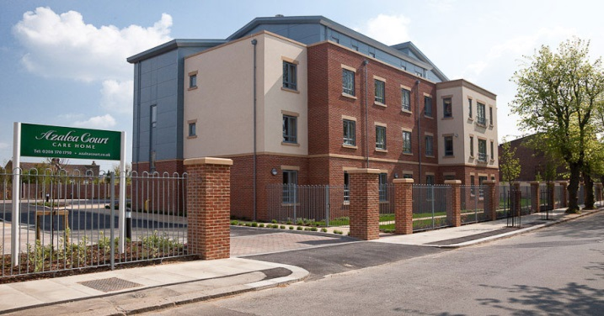

Welcome to the November edition of our new look newsletter.

This month’s newsletter is packed with information about all the exciting events we have planned for Christmas.

There is also a report from Danielle and Kathryn about their day at a NAPA conference and feedback from the latest relatives’ meeting.

# Welcome

Inside This Issue

Welcome

Activities

Fireworks

NAPA

Christmas

Relatives’ Meeting Feedback

Recommendations

Online

Birthdays

# Activities

This month we commemorated Remembrance Day with a service on Tuesday November 11th which was kindly led by members of Bush Hill Park Community Church. Representatives from the church visit us every month and details of their next service can be found on page four.

On Tuesday November 18th Brian Shaw entertained residents once again and he will be back next month to perform his Christmas themed show.

We also welcomed Tina’s Clothing on Wednesday November 19th with their winter range. They set up shop in the lounge and dining room on Astor and residents enjoyed browsing the rails.

On Saturday November 29th members of the Scouts will be visiting us for the first time.

They will visit all floors from 2pm and spend time socialising with residents.

We take many photos during activities and display these on the noticeboards so you can see what we’ve been doing. Below you will also find a selection of photos from our recent activities.

C:\Users\laura.payne\AppData\Local\Microsoft\Windows\Temporary Internet Files\Content.IE5\FK3FS814\MC900305493[1].wmf

On October 31st things took a spooky turn with Halloween themed activities.

Residents entered into the spirit of the day by dressing up and taking part in a variety of games.

Great fun was had by all.

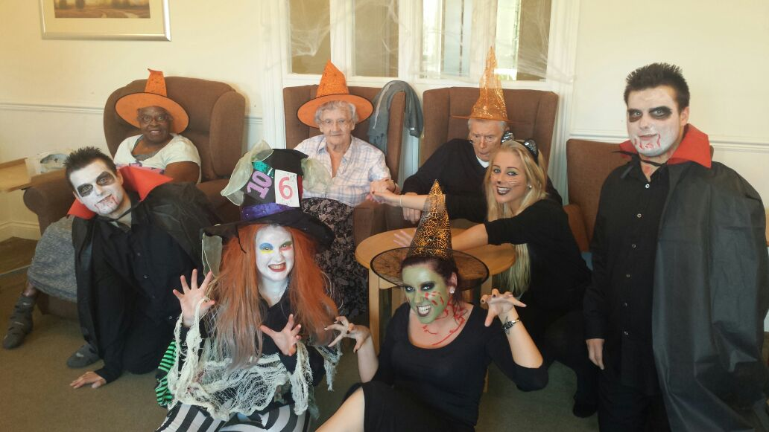

Azalea Court Newsletter

Twinglobe Care Ltd November 2014



# Fireworks

We held a fireworks party on November 5th which many of you came along to and we hope you enjoyed the evening. In addition to our own supply of fireworks Tesco kindly donated a selection of fireworks to us. Marcie Thomas, Tesco’s community champion for Enfield, visited Azalea Court and spent time chatting with our residents. Thanks to Alan for running the display and to Audra and her team who kindly provided burgers and hot dogs on the night which proved very popular.

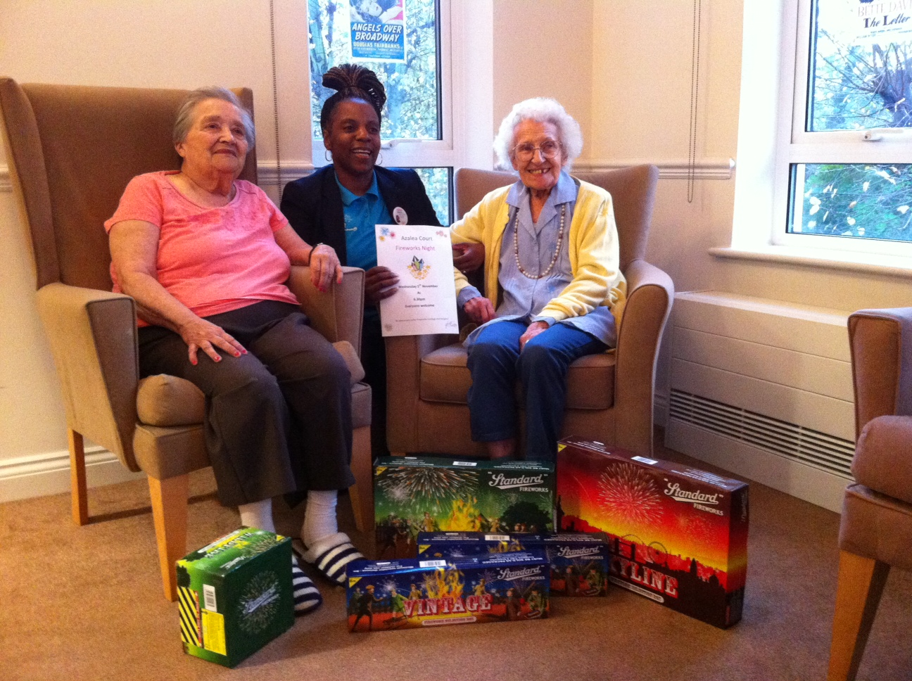



Over the last few weeks our residents have enjoyed regular trips to the coffee shop on Thursday mornings. If you would like your relative to go along please speak to the Activity Team.

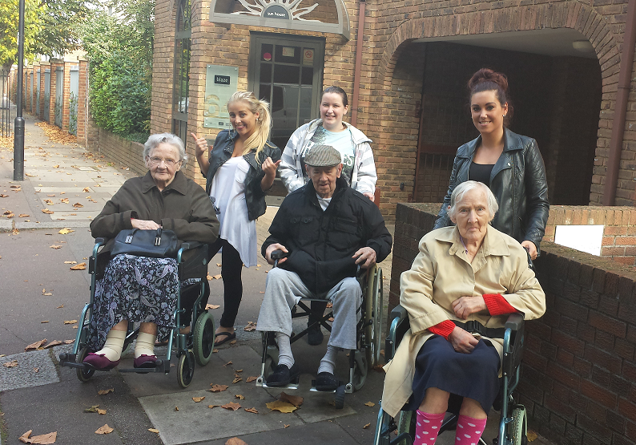

As mentioned in last month’s newsletter Danielle and Kathryn recently attended a training day run by the National Association for Providers of Activities for Older People (NAPA).

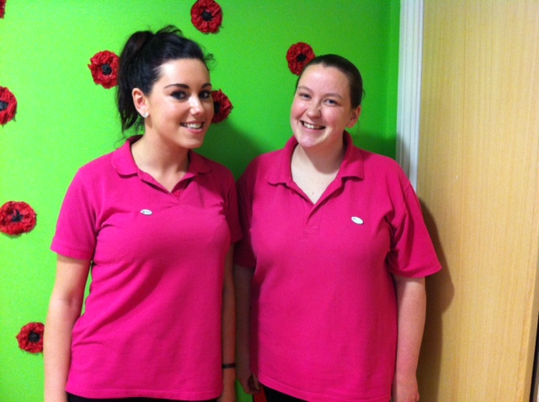

Here they give an insight into what they did on the day.

“Our day started when we arrived at the Victory Service Club in Marble Arch. We were greeted by NAPA representative Sylvie Silver who spoke about the organisation’s history and the importance of their work.

“We listened to talks from CQC where the speakers told us what they expect to see in activities and how they like things to be done.

“Later in the day we got to try out different products and gained information from a range of companies. One of the companies we tried was Opticians for Health. They had simulation glasses which allowed us to experience what it is like to live with different eye conditions. For example, Glaucoma showed us how you can only see with tunnel vision while for Maculate Degeneration we were nearly blind as all we could see was a black patch directly in front. Wearing the Cataracts simulation glasses made our eyes blurry and it was very hard to focus but you would still be legally allowed to drive which we found quite worrying. Lastly we experienced the view of someone who has had a stroke and we could only see half of the vision out of one eye.

“At the end of the day we took part in a fun group task where we got to make ‘Armpit Fudge.’ We made the fudge from scratch which included squashing it under our armpits!

“During the day we learnt vital information about certain eye conditions and we have looked at ways we can improve activities and adapt them to accommodate the needs of our residents.”

# NAPA

Are you getting that festive feeling? Well you certainly will be on Saturday December 6th when we hold our Christmas Bazaar. There will be a variety of stalls including gifts, sweets, Christmas lucky dip and refreshments while a number of brilliant prizes will be up for grabs in the raffle. Please speak to the Activity Team if you would like to donate a prize to our raffle or have any other quality items which you think would suit one of our stalls. The Bazaar will open at 2.30pm.

We will be running a trip to see the lights in London on December 17th, leaving Azalea at 4pm. For more information please speak to the Activity Team.

As well as the trip to see the lights, December will be packed with festive events taking place at Azalea.

**On December 2nd Bush Hill Park Community Church will be leading a Christmas themed service at 3pm. There will be a selection of readings while residents will be invited to join in with the carols.

**Then on December 8th Brian Shaw will be performing his Christmas show at 3pm on Poppy.

** The Bury Street Singers will be at Azalea on December 12th at 2.30pm to lead a Christmas service filled with carols and readings. This will take place on Astor.

**Tickled Pink will be singing festive favourites in their Christmas Spectacular show on December 23rd on Astor at 2.30pm.

**Then on Christmas Eve the Activity Team will be hosting Christmas parties on all the floors at 2pm when they will also be giving out Christmas presents.

**The entertainment continues after Christmas with Brian Shaw who will be paying us his second visit of the month on December 29th. He will be singing at 3pm on Lavender.

For more information about any of the entertainment please check the noticeboards.

C:\Users\laura.payne\AppData\Local\Microsoft\Windows\Temporary Internet Files\Content.IE5\W3PX03PJ\MC900250802[1].wmf C:\Users\laura.payne\AppData\Local\Microsoft\Windows\Temporary Internet Files\Content.IE5\2HGAUT35\MC900285794[1].wmf C:\Users\laura.payne\AppData\Local\Microsoft\Windows\Temporary Internet Files\Content.IE5\FK3FS814\MC900363558[1].wmf

# C:\Users\laura.payne\AppData\Local\Microsoft\Windows\Temporary Internet Files\Content.IE5\W3PX03PJ\MC900436386[1].pngChristmasC:\Users\laura.payne\AppData\Local\Microsoft\Windows\Temporary Internet Files\Content.IE5\W3PX03PJ\MC900436386[1].png

# Relatives’ Meeting Feedback

Below is a message from Julie following on from November’s Relatives’ Meeting.

“Thank you to those of you who attended the meeting. It was good to have the opportunity to talk with you and share views and opinions. I have taken on board the points raised regarding the availability of drinks and I have put in place an observation schedule with the Deputy Home Manager to feedback directly to the families concerned. Thank you also for the positive comments. It is always good to hear when you think Azalea Court has got it right.

“During the meeting I was able to inform those present of my intention to remain as the Home Manager. It is important to me that Azalea Court has clear direction and I believe that I am best placed to do this for the home. I look forward to working with all the families in the future and would welcome you all to the next relative get together on the 12th December at 7.30pm. This is an informal gathering with Christmas Fayre and lots of chat.  I will be updating you every month in the Newsletter of how we are moving forward and new appointments. I welcome any comments you may have and a suggestion box will soon be seen in reception so that I can hear what you have to say as well.

“Sam Freeman is my secretary and she can be found in the office on the first floor just by the lifts.

“Don’t forget we have the feedback forms in reception as well for you to complete.”

To all our residents celebrating this month we would like to wish you a Happy Birthday.

C:\Users\laura.payne\AppData\Local\Microsoft\Windows\Temporary Internet Files\Content.IE5\2HGAUT35\MC900430219[1].wmf

# C:\Users\laura.payne\AppData\Local\Microsoft\Windows\Temporary Internet Files\Content.IE5\2HGAUT35\MC900021592[1].wmfBirthdays C:\Users\laura.payne\AppData\Local\Microsoft\Windows\Temporary Internet Files\Content.IE5\2HGAUT35\MC900021592[1].wmf

We post all the latest news and photos on our website and Twitter.

You can log on to [www.twinglobe.com](http://www.twinglobe.com) or follow us on Twitter @twinglobe.

# Online

We are always interested in hearing what you have to say about the services we provide. Recommendation cards are available in reception and we would be grateful if you could take the time to fill one in.

These comments are sent to [www.carehome.co.uk](http://www.carehome.co.uk) and you can also submit feedback on their website.

In addition we also have a compliments book in reception where you can leave your comments and this is checked regularly by management.

# Recommendations