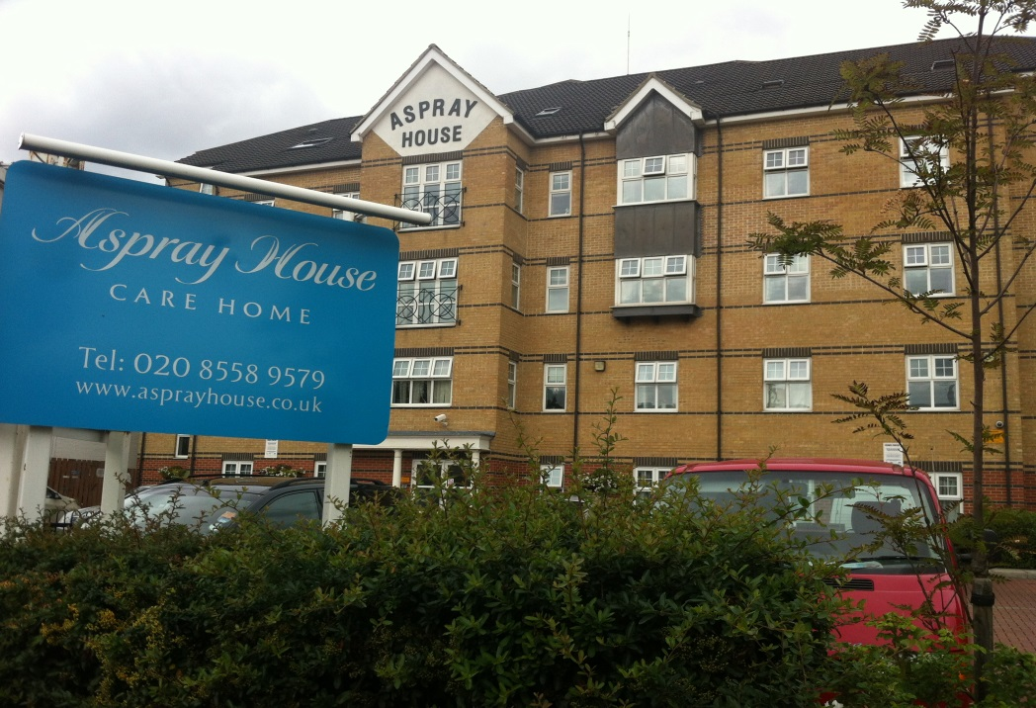

Contents
• • •
Welcome
Activities
Southend
Tour de France
Sky TV
Online
Home Decoration
Birthdays

Aspray House
481 Lea Bridge Road
London
E10 7EB
Tel: 020 85589579
Aspray House Newsletter
Twinglobe Care Homes Ltd |  | July 2014

Welcome
Welcome to July’s newsletter. In this edition you find all the latest news and information from Aspray House including plans for our trip to Southend.

Activities
We had a fantastic time celebrating National Care Home Open Day on June 20th. The day began with a visit from Shakti who got all the residents singing along then in the afternoon we held a Tea Party. The lounge on the second floor was decorated for the occasion with traditional bunting and residents enjoyed listening to music while tucking into their tea and cakes. Thanks to everyone who came along.
This month we will be welcoming Dream Worldwide Productions to Aspray House for the first time on Friday 18th. Their show Strictly Musicals features medleys from classics such as Singin’ in the Rain, West Side Story and The Wizard of Oz.
Looking ahead to August Chris will be singing once again on August 8th and we are keeping our fingers crossed for a sunny day so residents can enjoy the music in the garden.
Southend
We are off to Southend on July 16th to enjoy some sea air and a fish and chip lunch on the sea front. We are pleased to see that some relatives will be joining us for the outing and we are keeping our fingers crossed for a sunny day.
The trip has been arranged by the Activity Team and they are looking to arrange further outings in the coming months. If you have any suggestions for places to visit, please let them know.
Tour de France
There was an air of excitement around Aspray House on Monday July 7th as we gathered to see the Tour de France go past. Residents watched from the roadside and the lounges where they had a great view of the race leaders as they whizzed by, followed a short while later by the peloton. If you were watching on the television you may have just caught a glimpse of Aspray as the home was captured on camera.
Sky TV
As mentioned in our last newsletter we are delighted to inform you that you can now have Sky TV in your room. Thanks to our partnership with Sky we have secured an excellent rate and for your convenience payments would be made directly to us with a notice period of just 30 days.
There are various packages available to suit your interests so if you would like to have Sky in your room please contact Laura by calling 0208 3701750.
Online
Do you know you can recommend Aspray House online? Just log onto www.carehome.co.uk to have your say.
For latest news and photos you can follow us on Twitter @twinglobe or visit our website www.twinglobe.co.uk.
Home Decoration
On July 8th we began decorating Aspray House. The work will be completed in approximately 60 days and every effort will be made to minimise disruption. We would like to apologise in advance for any inconvenience.
Birthdays
To all our residents celebrating this month we would like to wish you a Happy Birthday.

