Contents
• • •
Welcome
Staff Update
Events
Church
Activity Schedule
Summer Fete
Volunteers
Southend
Sky TV
BBQ
Dining Room
Pictures
Online
Birthdays

Azalea Court
58 Abbey Road
Bush Hill Park
Enfield
EN1 2QN
Tel: 0208 3701750
Azalea Court Newsletter
Twinglobe Care Ltd |  | July 2014

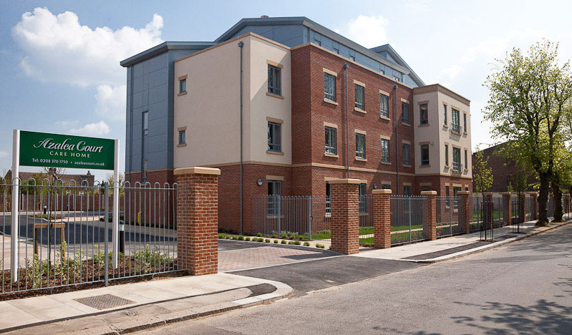

Welcome

Welcome to the fifth edition of our newsletter.
In this month’s issue you will find all the latest news and information from Azalea Court including the date for our BBQ and plans for our Summer Fete.
Staff Update
We would like to welcome Manasseh Dau (Dau) to Azalea Court as our new Deputy Home Manager. Dau has also been appointed as the Unit Manager for Astor and brings a wealth of experience to the role having spent over 30 years working in the health industry including 10 years in care homes. If you need to speak to Dau his office can be found on the second floor next to the Activity Room.
Events
We threw open our doors for National Care Home Open Day on June 20th when the Activity Team decorated the garden with playing card bunting and a grinning Cheshire cat for our Mad Hatter’s Tea Party. Residents donned hats they had helped to make during arts and crafts sessions as they tucked into tea and cakes while listening to singer Anna Jolley.
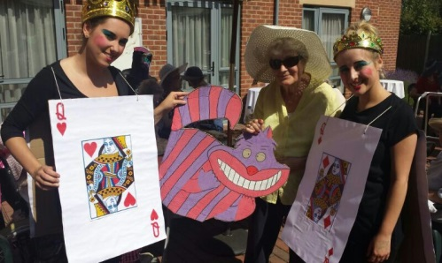
We also held a raffle and raised over £100 for the residents’ fund. As well as National Care Home Open Day our party was also part of NAPA’s Best Tea Party Ever competition. NAPA, the National Association for Providers of Activities for Older People, is a charity which provides activity ideas and training and we will be sending them photos to show what we did on the day. Thanks to everyone who came along to our Tea Party.
This month we will be welcoming the wonderful Tickled Pink to Azalea Court once more. On Thursday July 31st they will entertain residents with their show Swell Party featuring classic songs from the 1950s such as Johnny B Goode and Rock Around The Clock.
And in August other favourites will be back at Azalea Court. Residents will recognise familiar tunes when Brian Shaw brings his show Cockney Capers to us on Tuesday August 5th while singer Jodie Stone will be wowing us once again on Wednesday August 13th.
Church
For the last few months members of Bush Hill Park Community Church have kindly given up their time to visit Azalea Court. They will be here on the first Tuesday of every month to lead a service in the Quiet Lounge on the ground floor from 3pm. The service is open to everyone.
Activity Schedule
In August the Activity Team will switch floors to be organised as follows:
Astor – Daisy Lavender – Kathryn Poppy - Danielle
If a member of the Activity Team is absent because of annual leave or sickness their floor is covered by Veronica and the rest of the team.

Summer Fete
We are counting down the days until our Summer Fete on Saturday August 30th at 2pm. There will be a variety of stalls in our garden including tombola, bric-a-brac and games while refreshments will be available throughout the afternoon. Entertainment will come from singer Lynda Styan who will be performing classic songs from the 1920s, 30s and 40s. And there will be a chance to win in our raffle. If anyone would like to donate a prize for our Summer Fete raffle or if anyone has anything they would like to donate to one of our stalls, please speak to the Activity Team.
Volunteers Could you give up some of your time to help out at our Summer Fete? If you are interested please speak to the Activity Team. Contact Veronica by calling 020 83701750.
Southend We are off to Southend on August 19th. Despite the unseasonable weather last year everyone loved tucking into fish and chips by the sea and we can’t wait to do it all again.
You can sign-up for the trip in reception or speak to the Activity Team for more details. Places will be given on a first come first served basis, space permitting, and your spot will be confirmed by the Activity Team.
Sky TV
As mentioned in our last newsletter we are delighted to inform you that you can now have Sky TV in your room. Thanks to our partnership with Sky we have secured an excellent rate and for your convenience payments would be made directly to us with a notice period of just 30 days.
There are various packages available to suit your interests so if you would like to have Sky in your room please contact Laura by calling 0208 3701750.
BBQ
You are warmly invited to our BBQ on Friday July 25th at 7.30pm where you will have the chance to chat to staff while relaxing in our garden.
We are also excited to announce that Thorntons Chocolate will be there with some mouthwatering chocolates for you to try.
And you can completely give in to temptation as your favourites will be available to buy.
If you would like to attend please sign-up in reception or call 020 83701750 .We hope to see you there.
Dining Room
The dining room on Lavender will be out of use on July 21st and 22nd to allow for the flooring to be replaced. Alternative arrangements will be made for meal times.
We apologise for any inconvenience this causes.
Pictures
We are putting up new scenic pictures in every bedroom. Information can be written on the reverse of each picture by staff as well as relatives and this will include a summary of individual care needs.
Online
Did you know you can recommend Azalea Court online? Just log onto www.carehome.co.uk to have your say.
For latest news and photos you can follow us on Twitter @twinglobe or visit our website www.twinglobe.co.uk.
Birthdays
To all our residents celebrating this month we would like to wish you a Happy Birthday.

