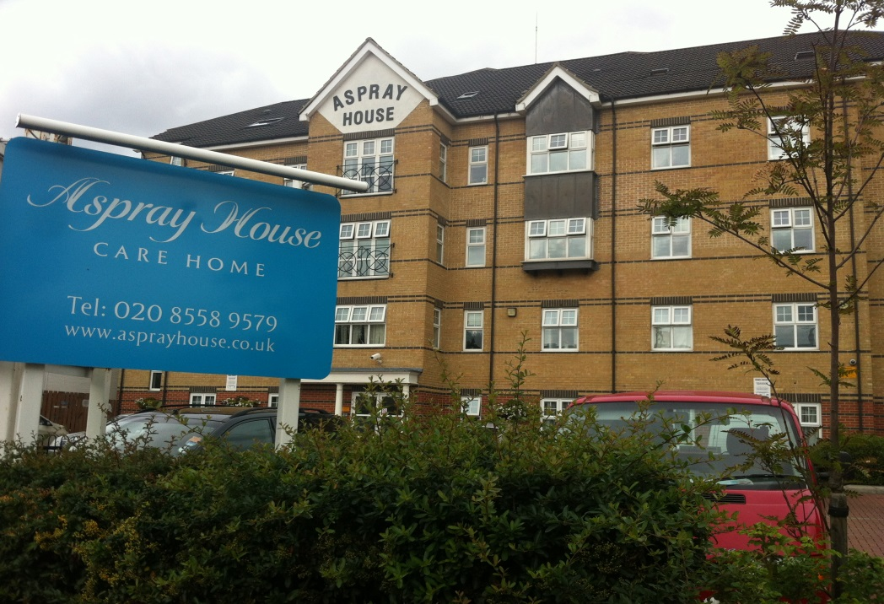

Contents
• • •
Welcome
Activities
Car Boot Sale
Farm Visit
Café
Online
Recommendations
Birthdays

Aspray House
481 Lea Bridge Road
London
E10 7EB
Tel: 0208 5589579
Aspray House Newsletter
Twinglobe Care Homes Ltd |  | September 2014

Welcome
Welcome to the September newsletter from Aspray House. In this month’s edition you will find the dates of our upcoming shows as well as details about our plans for a café.

Activities
We have a variety of performers lined up over the next couple of months for our residents to enjoy.
- Friday September 19th Just Jan.
- Tuesday September 30th Olivia’s Musical Memories.
- Tuesday October 14th Olivia’s Musical Memories.

- Thursday October 16th Shakti.
- Thursday October 30th Dream Worldwide Productions Monster Mash.
As well as organising the entertainment, the Activity Team are in the process of decorating the Activity Room following on from the recent re-painting throughout the home. The room is already looking a lot brighter and we hope residents will enjoy using the new look space once it is complete.
Car Boot Sale
Thanks to everyone who came along to our Car Boot Sale on Saturday September 6th. We raised nearly £50 which will go towards our residents’ fund. We will you let you know about any future events in our newsletter.
Farm Visit
Residents enjoyed a recent outing to Brooks Farm with the Activity Team. The farm is just a few minutes from Aspray House and residents were able to get up close to a number of animals including donkeys and rabbits.
Café
We are planning to transform the ground floor small lounge into a café to give residents and their families a place to sit and socialise together.
Therefore we are on the lookout for any unwanted china so if you have anything that you think may be suitable for us to use in our café, please speak to the activity team or call 0208 5589579.

Online
We are on Twitter. You can follow us @twinglobe for information on all the latest news and events as well as photos.
Recommendations
We would like to thank people for their kind comments about the services we provide here at Aspray House.
If you would like to give us your feedback then please fill in one of the recommendation cards available in reception by the signing in book. We are also listed on www.carehome.co.uk where you can add your recommendation.
Birthdays
To all our residents celebrating this month we would like to wish you a Happy Birthday.

