Contents
• • •
Welcome
Summer Fete
Activities
Southend
Residents’ Meeting
Recommendations
Online
Birthdays

Azalea Court
58 Abbey Road
Bush Hill Park
Enfield
EN1 2QN
Tel: 0208 3701750
Azalea Court Newsletter
Twinglobe Care Ltd |  | September 2014

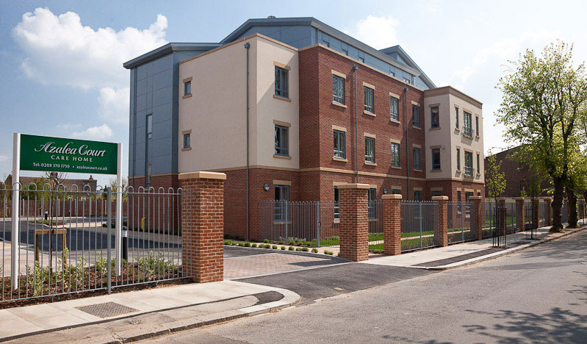

Welcome

Welcome to the September edition of our newsletter. This month’s issue is packed with photos from our Summer Fete and the residents’ trip to Southend.
Summer Fete
We held our Summer Fete on Saturday August 30th and are delighted to announce that we raised nearly £1,000 which will go to our residents’ fund.
We welcomed visitors to the garden at Azalea Court including Enfield Mayor Ali Bakir who officially opened the fete by cutting the ribbon and saying a few words. He then spent time looking around the stalls and greeting residents. We would like to thank him for attending.
Our range of stalls and games included bric-a-brac, tombola, face painting, guess the weight of the cake, sweets and lucky dip. The afternoon ended with the calling of the raffle. Thanks to everyone who donated items for our stalls and to the staff and volunteers who
gave their time to help out.
We hope everyone who came along enjoyed the afternoon. We look forward to doing it all again next year.
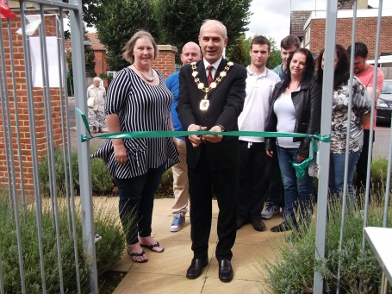
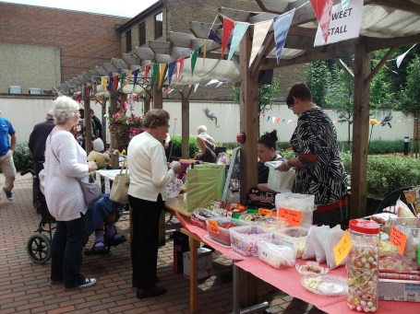
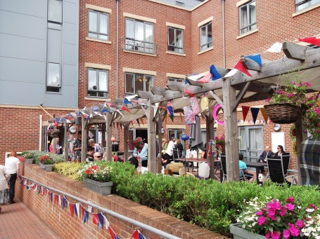
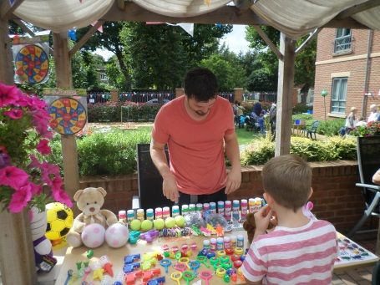

Activities
This month we have already welcomed Bush Hill Park Community Church for their monthly service and Mick Ryan who got the residents singing along to some classic songs.
And on September 12th the Bury Street Singers will be visiting Azalea Court once again to entertain residents.
There is plenty to look forward to in October with Tickled Pink returning to Azalea Court while the Activity Team will be busy planning some Halloween themed activities.
Southend
Since our last newsletter a group of residents have enjoyed a day trip to Southend.
They returned to the same seafront restaurant we went to last year for their fish and chip lunch. They then soaked up the sights and the sea air with a walk along the promenade.
Thanks to the staff and relatives who went along and made the trip possible. We hope everyone enjoyed their day.
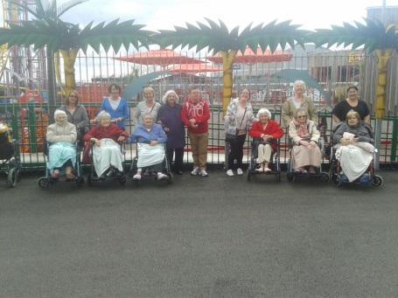
Residents’ Meeting
The Activity Team will be holding a residents’ meeting on Wednesday October 1st at 3pm in Astor Main Lounge. Please let them know if there’s anything particular you would like to discuss.
Recommendations
We would be extremely grateful if you could take the time to fill in a recommendation card as we are constantly looking at how to improve our services. The cards will shortly be available in reception so please look out for them.

Online
To keep up to date with all the latest news and events you can follow us on Twitter @twinglobe.

We always welcome your feedback about Azalea Court and, if you would like to, you can leave a recommendation online at: www.carehome.co.uk
Birthdays
To all our residents celebrating this month we would like to wish you a Happy Birthday.

