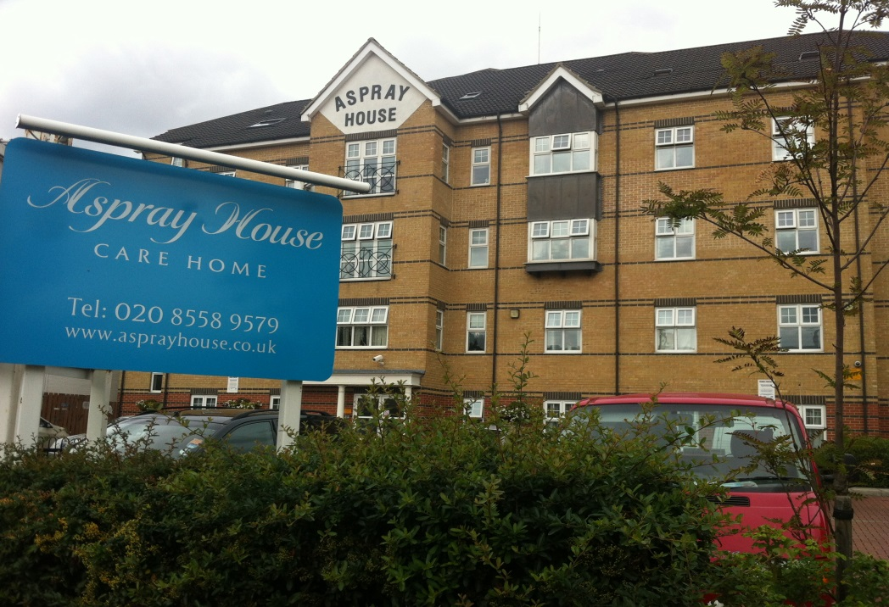

Contents
• • •
Welcome
Activities
Southend
Car Boot Sale
Commendation
Sky TV
Online
Birthdays

Aspray House
481 Lea Bridge Road
London
E10 7EB
Tel: 0208 5589579
Aspray House Newsletter
Twinglobe Care Homes Ltd |  | August 2014

Welcome
Welcome to the August newsletter from Aspray House. In this edition we look back at our wonderful trip to Southend and look ahead to the entertainment we have coming up.

Activities
During the last month the Activity Team has made the most of the sunny weather by taking residents out into the garden as often as possible to join in with activities.
This month we are looking forward to welcoming Chris to Aspray House on Friday August 8th while in September Just Jan will be singing to residents on Friday 19th.

You can find out what activities are scheduled each day by checking the notice boards by the lift or the notice board in reception as the daily programme is displayed there from Monday to Friday. Alternatively you can speak to the Activity Team and they will be able to tell you what activities they have planned.
Thanks to everyone who completed the activity part of our recent surveys. We received very positive feedback and all comments have been discussed with the Activity Team who will look to include suggestions in the future activity programme.
Southend
Last month we took a group of residents on a day trip to Southend. We had a brilliant day out with glorious weather.
Our first stop was for fish and chips at a restaurant on the promenade. The staff made us feel very welcome and everyone enjoyed their food.
Then with hats and sun cream in place we headed out into the sunshine for a walk along the promenade. We made sure we found time for an ice-cream and some of the residents were able to venture onto the beach.
Thanks to the staff who made the trip possible and the relatives who came along in support.

Car Boot Sale
Our next Car Boot Sale is taking place on Saturday September 6th from 10am until 2pm where we will be raising money for the residents’ fund.
Pitches cost £8 and if you would like to book one please speak to the Activity Team or call 020 85589579.
Commendation
Aspray House has been commended by the Clinical Commissioning Group for its care. On a visit to the home this month they praised the team for their tissue viability care as none of the residents had a pressure sore.
Sky TV
As mentioned in previous newsletters we have joined forces with Sky TV and it is now available to install in bedrooms at Aspray House.
If you would like more information please call 0208 3701750.
Online
We are on Twitter. You can follow us @twinglobe for information on all the latest news, events and photos.
You can also find us on www.carehome.co.uk where you can join others who have left a recommendation.
Birthdays
We always ensure we celebrate each resident’s birthday and a cake will be provided for the residents to share. If there is anything particular you would like us to do to mark the occasion, please speak to the Activity Team.
Happy Birthday to our residents who are celebrating this month.

