Contents
• • •
Welcome
Southend
Summer Fete
Activities
Sky TV
BBQ
Fire Brigade Strikes
Online
Birthdays

Azalea Court
58 Abbey Road
Bush Hill Park
Enfield
EN1 2QN
Tel: 0208 3701750
Azalea Court Newsletter
Twinglobe Care Ltd |  | August 2014

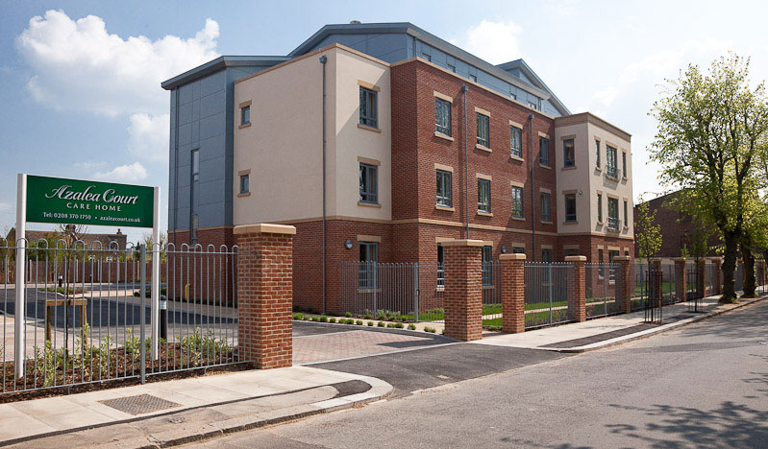

Welcome

Welcome to the August edition of our newsletter. This month we are looking ahead to our trip to Southend and our Summer Fete.
Southend Excitement is increasing as the date of our trip to Southend draws near. We are off on August 19th and we are looking forward to a great day out.
Already this summer a group of residents from our sister home Aspray House enjoyed a brilliant day out to Southend complete with fish and chips and ice-cream on the promenade.
To everyone going along, residents, relatives and staff, we hope you have a fantastic day.
Summer Fete
It is not long now until our Summer Fete on Saturday August 30th and we are pleased to announce that Enfield Mayor Ali Bakir will officially open the event at 2pm. We will have a number of stalls including bric-a-brac, face painting, lucky dip, hook-a-duck and tombola, plus refreshments and music from Lynda Styan.
The Activity Team will be selling raffle tickets in the run up to the fete and all money raised will go to the residents’ fund. If you would like to donate a prize for our raffle please speak to the Activity Team or call 0208 3701750 and ask for Veronica.
We look forward to seeing you there.
Activities
Over the last month residents have enjoyed spending time in the garden for activities and shows including most recently Tickled Pink who performed their show Swell Party on July 31st. And residents have been keeping cool while relaxing in the garden by dipping their feet in our paddling pools.
This month Brian Shaw will be performing his show Cockney Capers on Tuesday August 5th and on Thursday August 7th we will welcome members of Bush Hill Park Community Church for their monthly service in the Quiet Lounge on Astor starting at 3pm.
Looking ahead to September Mick Ryan will be singing at Azalea once again when he returns on Tuesday 9th.
For more information about the location of the shows please check the notice boards where the details will be advertised.
Sky TV
As mentioned in previous newsletters Sky TV is now available to be installed in bedrooms.
If you would like more information please call 0208 3701750.
BBQ
Thanks to everyone who came to our BBQ and Thorntons Chocolate event on July 25th. It was fantastic to see so many people out in the garden.

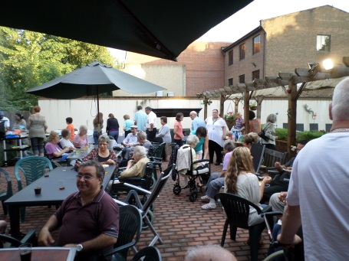
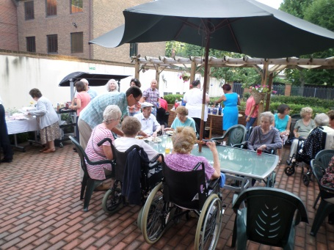
We hope you all enjoyed your evening.
If you have any ideas for future Relatives’ Evenings please speak to Janet as she is happy to hear your suggestions.
Fire Brigade Strikes
As you may have heard members of the Fire Brigades Union are planning to strike between 12pm and 2pm and 10.59pm and 11.59pm everyday from August 9-16. This will have an impact on the service provided by London Fire Brigade and as a result we are asking everyone to be extra vigilant during this time.

Online
To keep up to date with all the latest news and events you can follow us on Twitter @twinglobe.
We always welcome your feedback about Azalea Court. If you would like to leave a recommendation please visit www.carehome.co.uk
Birthdays
For each resident’s birthday we will provide a cake and decorate their room. If there is anything particular you would like us to do to mark the occasion please speak to the Activity Team.
We would like to wish all our residents celebrating this month a Happy Birthday.

