Contents
• • •
Welcome
Staff Update
Activities
Summer Fete
Projects
Outdoor Living
Sky TV
Online
Hairdressing
Feedback
Birthdays

Azalea Court
58 Abbey Road
Bush Hill Park
Enfield
EN1 2QN
Tel: 0208 3701750
Azalea Court Newsletter
Twinglobe Care Ltd |  | June 2014

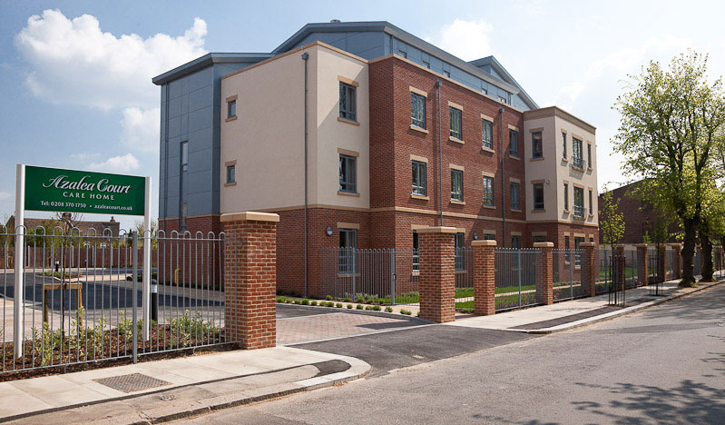

Welcome

Welcome to the fourth edition of our newsletter.
This issue features all the latest news and information from Azalea Court including staff appointments and dates for you diary.
Staff Update
There have been a number of new appointments since our last newsletter

Janet, who has worked at Azalea Court for the past seven months, is our new Home Manager. Janet brings a wealth of experience to the role from her previous positions as a Home Manager.

Following a successful recruitment campaign we have employed several new carers and we would like to welcome them to the team.

Other new appointments include Simona who was the Unit Manager on Astor from 2012 and she is now the Night Manager.

Elsewhere Veronica has joined our team as the Activity Organiser. Veronica’s background is in activity management and she will be responsible for overseeing activity provision at Azalea. Veronica can be found in the Activity Room on the second floor where Kathryn, Daisy and Danielle are also based.

Poppy now has a ward clerk. Naomi is working to achieve her apprenticeship in administration and we hope this new role will prove successful.
And Natalie has joined our team as our new Receptionist.

We would like to wish everyone the best of luck in their new roles.

Activities
Don’t be late for our very important date - Friday June 20th – when our garden will be transformed into the world of Alice in Wonderland for our Mad Hatter’s Themed Tea Party. From 2pm there will be games, music from singer Anna Jolley, food and, of course, hats. Residents are currently making their hats during activities so why not come along on the day, join in the fun and remember to bring a hat.
Our party is taking place as part of NAPA’s Best Tea Party Ever and we are a member of NAPA, the National Association for Providers of Activities for Older People. The organisation runs training events and activity competitions throughout the year including the Best Tea Party Ever contest. We will be submitting photos after the event so look out for our camera on the day.
If it decides to rain the Tea Party will be hopping into the Lounge on Astor.
Looking further ahead, Tickled Pink will be back on at Azalea Court on Thursday July 31st with their show Swell Party featuring classic songs from the 1950s such as Johnny B Goode and Rock Around The Clock.
Moving into August and Brian Shaw will return on Tuesday August 5th with his show Cockney Capers while singer Jodie Stone will be wowing us once again on Wednesday August 13th.

Summer Fete
This year our Summer Fete will take place on Saturday August 30th at 2pm.
There will be a variety of stalls and games in the garden and we will welcome singer Lynda Styan for the first time. She will perform classic songs from the 1920s, 30s and 40s during the afternoon.
There will also be some great prizes up for grabs in our raffle. We would like to thank everyone who has donated prizes to us in the past and if you would like to donate to our next raffle please speak to the Activity Team.
Projects
The Quiet Lounges are currently being given a makeover by the Activity Team.
Each room has been given a theme and on Astor the lounge will be transformed into a library to create a place where residents can relax with a book or have a book or paper read to them.
Meanwhile on Lavender a reminiscence room is being created and the lounge on Poppy will be turned into a cinema room.
We would love for you to get involved. Maybe you have some sports equipment you no longer use or records you no longer play. If you have anything which you think could enhance any of our lounges then please let the Activity Team know.
We are hoping to establish a knitting group and welcome any donations of wool or patterns. We also plan to create a gentleman’s group for the men of the home to give them time to socialise together to chat or play card games.
If you have anything which you think would be of use in our activities please speak to the Activity Team.
Outdoor Living
Our residents have already enjoyed being out in the garden this year thanks to the spells of warm weather. We always look to hold activities in the garden whenever possible and we have recently bought a number of outdoor games including skittles, croquet and darts.
Our hanging baskets are nearly ready so there will soon be a touch more colour at the front of the home as well as in the garden.
Sky TV
We are delighted to inform you that you can now have Sky TV in your room. Thanks to our partnership with Sky we have secured an excellent rate and for your convenience payments would be made directly to us with a notice period of just 30 days.
There are various packages available and we are currently in the process of finding out how many residents are interested.
Online
We have some new features on our website. There is now a news and events tab where we will be posting information about the latest developments at Azalea Court including upcoming events and our newsletters.
Our galleries have also been re-designed to make the photos more accessible. To take a look please log on to www.twinglobe.co.uk
For latest news and photos you can follow us on Twitter @twinglobe
Hairdressing
Alvaro from Hair Dimensions is increasing some of his prices. From June 1st there will be a £1 rise for some of his cuts and treatments. A full price list is displayed on the hair salon door. Please speak to Activities for more information.
Feedback
We want to hear from you. A survey has been sent out and we would be extremely grateful if you could take a few moments to fill it in.
Your feedback is very important to us and we will read all your comments to see what you think is working well and how we can make Azalea Court even better.
Birthdays
We would like to wish all our residents celebrating their birthdays this month a very Happy Birthday.

